Drag and Drop the tool options and complete the flowchar

**(PART - B)**

(TO BE COMPLETED BY STUDENTS)

(Students must submit the soft copy as per following segments within two hours of the practical.

The soft copy must be uploaded on the Blackboard or emailed to the concerned lab in charge faculties at the end of the practical in case there is no Black board access available)

|  |  |
| --- | --- |
| Roll.No. : | Name: |
| Sem/Year : | Batch: |
| Date of Experiment : | Date of Submission: |
| Grade -- |  |

# B.1: Procedure of performed experiment

To Find simple interest

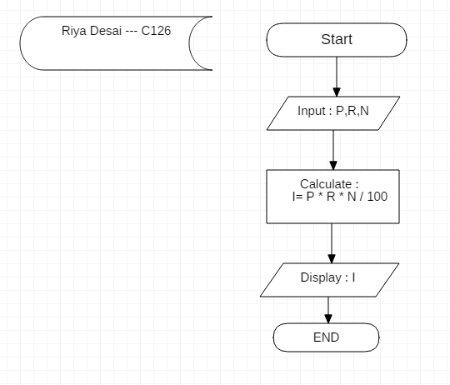

To Find area of a circle

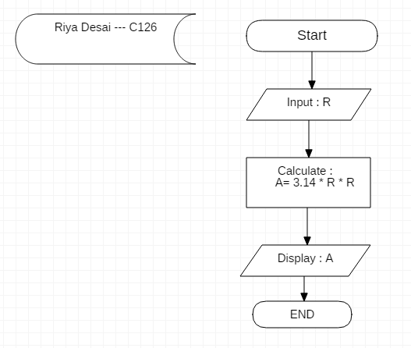

To Find sum digits of given integer number

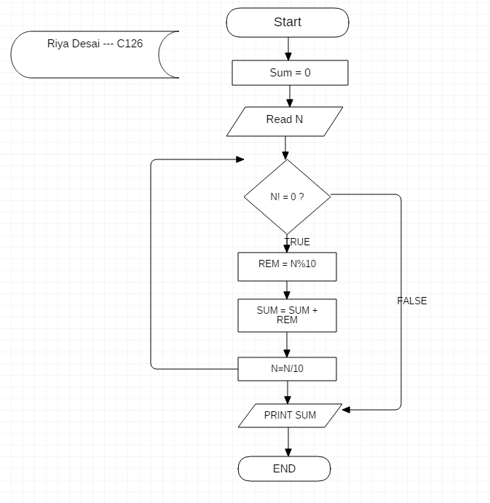

To check whether a given number is divisible by 3 and 7 or nor

# 

To check whether the given number is prime number or not

# 

To Print all prime numbers in the given range.

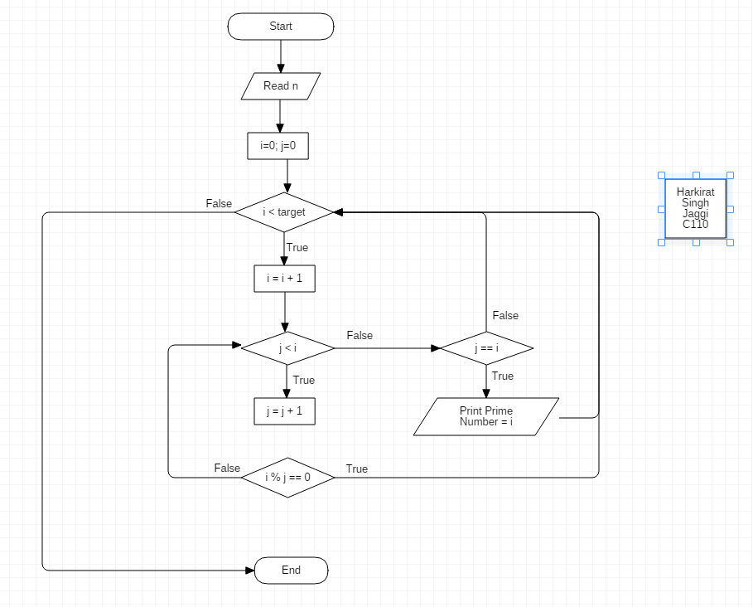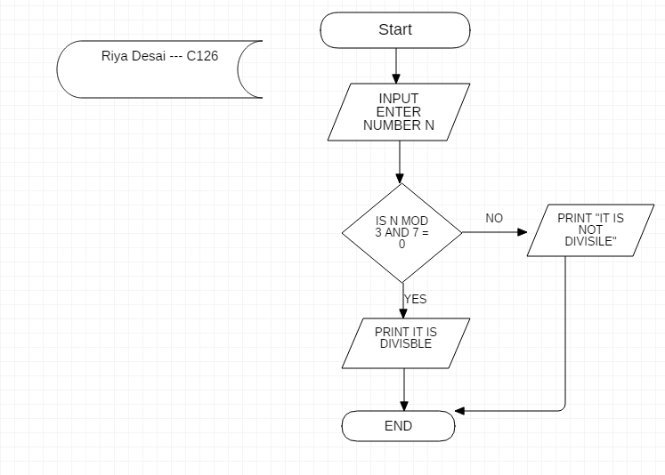

# B.2: Observations and Learning’s:

Learnt how to use staruml

# B.3: Conclusion:

Learnt how to make flowchart